[](http://www.google.co.uk/url?url=http://www.ysgolycastell.org/2015/11/27/weekly-blog-by-kara-and-isaac/&rct=j&frm=1&q=&esrc=s&sa=U&ved=0ahUKEwiXvc3yh7jJAhUByhoKHQIsAs8QwW4IHDAD&usg=AFQjCNGlIRvUqVeOsaeoKTcoMEwonq48iQ)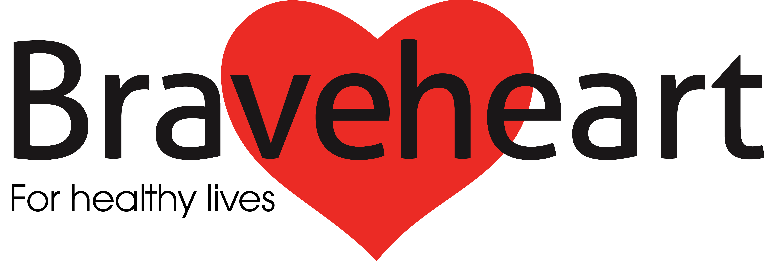

**Braveheart has had a super year and would like to share with everyone the last few achievements of 2015! We wish all our Volunteers and service users a merry Christmas and a happy New Year!**

**Braveheart’s next newsletter is due out in April 2016!**

**Braveheart’s Christmas Newsletter 2015**

We finish 2015 having led over 340 walks, welcomed over 4400 attendances, and completed 14 Monthly Walks!

We start 2016 with our brand new Polmont day walk! Every Monday, 10.30am leaving from Polmont Community Hall Car Park. Walk Leader Helen looks forward to seeing you there.

**\*\*Starting 11th January**\*\*

***Walk with Braveheart***

Braveheart celebrated the past 10 successful years of Walk with Braveheart and how our programme is flourishing as we enter a new 10 years! We celebrated with our yearly Sponsored Walk, raising over £350. We chose Callender Park to have our walk as this is where our programme first began many years ago! A massive thank you to everyone who joined us for our walk, and to our Volunteers for their ongoing enthusiasm and commitment.

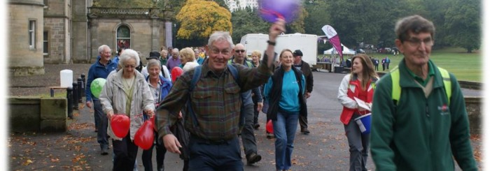

Our programme goes from strength to strength as we start two new walks in Clackmannanshire; our friendly Walk Leaders enjoy leading a short and longer walk around the Hawkhill area each week.

The Advisory Group (TAG) invited Braveheart to their Summer Ball and presented us with a cheque for over £450! TAG chose Braveheart as their Charity of the year in 2015. We can’t thank TAG enough and would love to continue partnership working in the future.



***Key Achievements***

* Clackmannanshire Walk Development
* Braveheart welcome new Walk Leaders
* New Health Mentors trained
* £350 raised from Sponsored Walk
* Community Challenge Champions!
* TAG present cheque to Braveheart
* Paths for All recognition certificate

Braveheart’s AGM

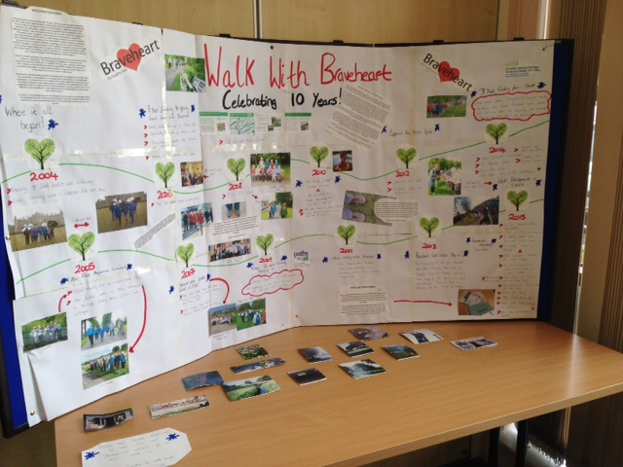

**AGM Display- 10 year timeline of Walk with Braveheart**



# images.jpg

# images.jpgimages.jpgimages.jpgimages.jpg

***Health Mentoring***

Braveheart is introducing a new free Weight Management group.

Delivered by trained Health Mentors over 12 weeks, the programme will provide you with guidance and practical advice on weight and making lifestyle changes

* you’ll explore your relationship with food,
* learn how to make healthy choices
* keep a food diary
* participate in a weekly weigh-in

If you are interested in taking part call Maureen on 01324 673706

# images.jpg

***2016 Goals***

* More walking opportunities
* Further links with community groups
* Closer partnership working with NHS and local organisations

# 

Please turn over…

# **bells.jpgChristmas GROWL (GRumpy Old Walk Leader)**

Well hullo again fellow walkers, although wi' the weather recently the walkin's been curtailed a bit. Nothing but wind and rain and mud up tae yer ankles – and that's just indoors! Mind ye, we're no as bad as the Western Isles, a' they howlin' gales (and howlin' Gaels).

Ah was oot for a walk this mornin' and whit caught my eye, apart fae a tree branch that ah didnae notice, wis the amount o' litter aboot. It's worse the noo wi' the leaves bein' off the trees and the vegetation dyin' doon. Nothin' but empty cans o' lager, green bags full o' God knows whit, discarded fast food bags and the odd black bin liner that's got caught in a tree. Whitever happened to the scaffies that used to go roond wi' the dustcart on wheels, wi' their brush and shovel? Bring them back ah say, they were worth their weight in gold.

Talkin' o' fast food, ah wis readin' in the paper aboot how North Lanarkshire had tae climb down fae bannin' a' they burger vans fae ootside the school gates, as they were deprivin' the weans o' their “human rights”! We never had burger vans (we never had burger all) ootside oor school. Ye just went hame and yer mam had the chip pan full o' lard cooking away yer sausages and chips. Aye but ye also got yer meat and 2 veg, hame-made soup and fruit and custard.

Mind ye, ah don't know how ma teeth survived ma mother's empire biscuits, Viennese fingers, flea cemeteries etc., no tae mention ice poles, spangles, opal fruits and Smith's crisps wi' the wee blue bag o' salt – if ye were lucky ye got two bags, but other times there wis nane. But there were very few fat weans, we a' ran aboot and cycled everywhere and yer folks didnae worry because they knew ye'd be hame for yer tea!

Ma wife says ah'm an auld pedant. She's right enough. A' they misprints and misplaced apostrophes get ma goat. Ah wis readin' a menu the other day and they had Creme Burlee for dessert! Creme Burlee. The Burlee wis never the crème when ah wis goin' aboot, ye had tae be burly tae avoid getting' intae a barney!

Well that's a' ma greetin' and groans for another wee while. Hope ah've cheered ye up!

By Walk Leader Ian Parker

Will be sadly missed on our Braveheart Walks

*George Lyons

Feel free to contact Braveheart with suggested news for our next newsletter: 01324 673703

*Please look out for our new Weekly and Monthly Walk Cards for 2016*

# 