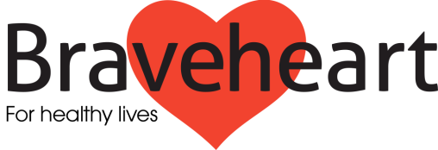

Volunteer Health Mentor Agreement

Name of Volunteer……………………………………………
Address……………………………………………………………………………....

……………………………………………………. Postcode………………………
Home/Mobile…………………..…………………………………………………
Braveheart Named Contact:……………………………………………

The following areas of volunteering and responsibilities have been agreed between the volunteer named above and Braveheart:

Main Activities

The main activities of volunteer health mentors are:
- To facilitate mentor group sessions in the community
- To help increase participants’ knowledge about their condition/health and help them to achieve and maintain a healthier lifestyle.

- To support participants in making lifestyle changes that will maintain their independence and well-being and reduced the likelihood of unplanned hospital admissions
- To carry out appropriate administration procedures for example recording attendance at mentor groups

- To support evaluation of the project, i.e. ensuring participants to the programme complete initial and final evaluation forms

Availability
Volunteers are expected to be available to assist with Braveheart mentoring activities as required and agreed. Braveheart recognises that flexibility is a key element of our agreement with volunteers.

Induction and Training
Before starting as a volunteer with Braveheart the volunteer will participate in an induction session and will receive appropriate training. This will consist of:
- Braveheart Information session and interview by Development Officer
- Braveheart Health Mentor Training Course (35 hours)
Contact Person
Volunteers will be supported and supervised by the Braveheart Development Officer.

Attendance at Volunteer’s Meetings
The volunteer is expected to attend volunteers’ meetings held in the evening every six weeks at Falkirk Community Hospital.

Expenses
Travel and other out of pocket expenses will be paid in accordance with The Braveheart Association’s guidance on the reimbursement of Volunteers Expenses’ Procedure. Volunteers are asked to hand these in each month.
Some volunteers may choose to donate all or a proportion of their out of pocket expenses back to Braveheart. If you wish to donate in this way please indicate this on the expenses claim form.

Insurance
While volunteering on behalf of The Braveheart Association, the volunteer is covered by the organisations insurance, whilst they are on premises occupied by Braveheart or, when engaged in any activities on behalf of the organisation, provided these activities are being conducted within their role description. If a volunteer task involves driving, Volunteers are advised to check with their Motor Insurance Company to confirm that they are covered for volunteer driving.

Counselling Out/Dismissal
The Braveheart Association reserves the right to end the services of volunteers, if, in its opinion, volunteers have been negligent of their duties, have behaved unacceptably or prove to be unsuitable.

Grievance Procedure
If the volunteer has a grievance that cannot be resolved with their named contact, it should be referred to the Braveheart Manager. Should his/her ruling be disputed, an appeal against it will be considered by the Braveheart Board. Their decision is final.
Equal Opportunities
The volunteer is expected to carry out their tasks in accordance with The Braveheart Associations Equal Opportunities Procedure.

I agree with the conditions set out above.

Signed………………………………… (Volunteer) Date…………………….

Signed………………………………… (Named Contact) Date………………….…

Please return to:
The Braveheart Association
Falkirk Community Hospital
Majors Loan
Falkirk
FK1 5QE

